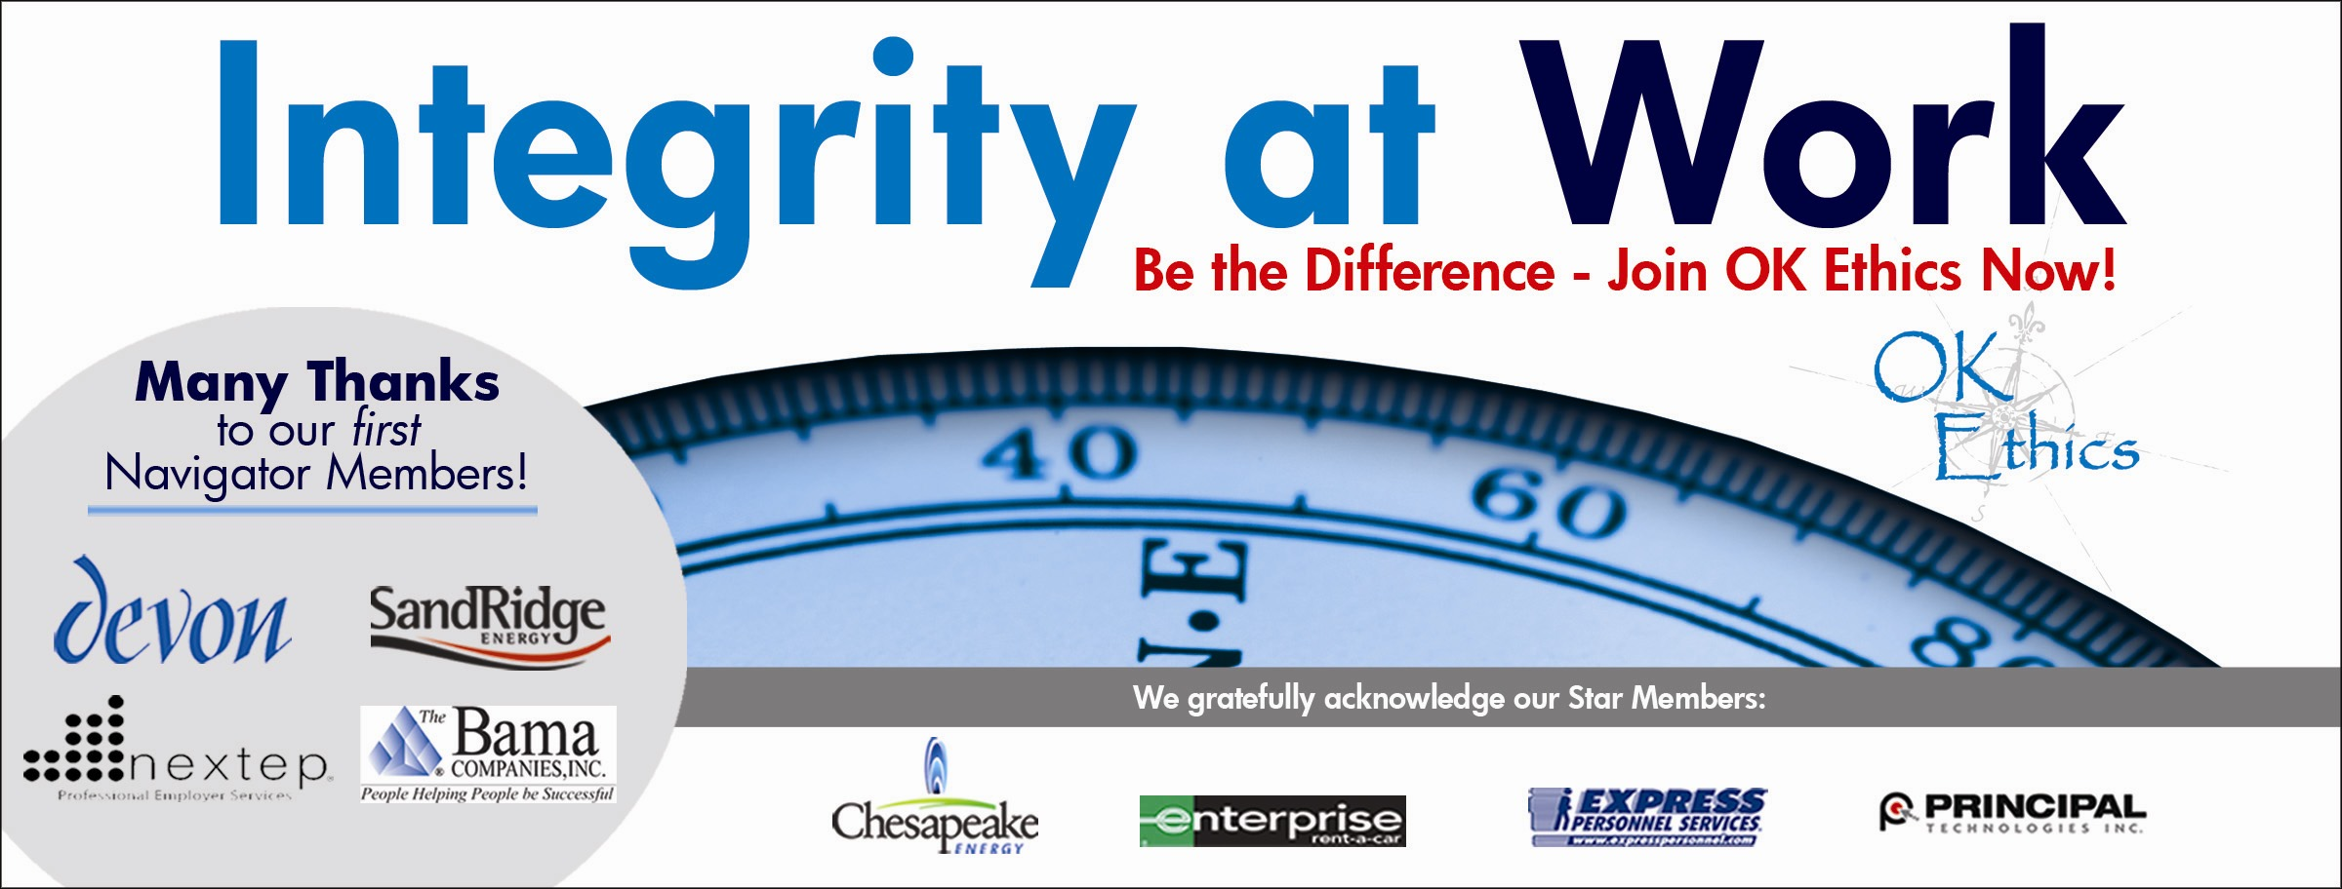

Oklahoma Business Ethics Consortium
Tulsa Chapter

May 22, 2008 – 11:30 a.m. to 1 p.m.

- Welcome and special recognition (11:45 -11:50) John Stancavage, Tulsa World
Special thanks to OkEthics members Nick Minden, Michael Oonk, Carol Swarthout, Lynn Flinn, Royce Kelly, Lori Rowan, Whitney Mathews, Shannon Warren and Jenny Lizama for their help with this meeting.

II. Guiding Principle (11:50 – 11:55) Royce Kelly, Spirit Bank
The Oklahoma Business Ethics Consortium’s activities are conducted under a set of guiding principles.

III. Introduction of panel (11:55-noon) Lynn Flinn, The Rowland Group

IV. Panel Discussion "How Good Organizations Turn Evil" (Noon – 12:50)

Moderator: Kevin Kennemer, President, The People Group LLC

Panel
Dr. Raj Basu, Vice President for Academic Affairs for Oklahoma State University, Tulsa. As the Chief Academic Officer of the university, he has overall responsibility for operations, development, and promotion of all academic programs. Dr. Basu researches and teaches in the areas of leadership, employee performance, team building, and change management. He also consults with organizations in the aerospace, energy, financial services, technology, government, and non-profit sectors. His research has been published in many journals, including the Journal of Applied Social Psychology, Journal of Employee Assistance Research, and International Journal of Stress Management.

Dr. Charles “Cappy” Leland, Ed.D., founder and CEO of Performance Dashboard in Edmond, Okla. Performance Dashboard is the publisher of diagnostic organizational wellness and performance feedback assessment tools. Dr. Leland understands that applying what we know about health and strong organizations enables us to screen for undetected "toxic" symptoms before they become a serious issue. Having such feedback provides an early warning system enabling decision makers to address and resolve those issues before they adversely impact the balance sheet or P&L.

Keith Chappell, senior engineering functional manager in charge of The Boeing Co. Oklahoma City Site Engineering Tools, Processes, People and Technology. He has 15 years of diverse engineering, management and leadership experience. He is responsible for developing and executing the strategic vision for the engineering organization. Keith received the Support Systems Atlas Award, Silver Award for Technical Excellence and the Bonnie Small Award for Quality Excellent demonstrating his dedication to customer satisfaction.

Ryan Ross, director of Alliances and Partners for Hogan Assessment Systems, an international leader in personality assessment for employee selection, career development, and talent management. Working with such clients as Bank of America, Dell and AT&T, Ross is a world-renowned authority on pre-employment selection and individual development practices; he is an industry expert in criterion-related and validity generalization based implementation of personality assessments. Mr. Ross holds an Industrial/Organizational psychology degree and is a member of the American Psychological Association and Society for Industrial and Organizational Psychology.

V. Membership update Whitney Mathews, The Rowland Group

VI. Closing remarks (1 p.m.) John Stancavage

Ok Ethics

UPCOMING EVENTS

Tulsa Chapter

- June 26 – "Inside Community: The Dynamics of Behavior," with Clifton L. Taulbert, president and founder, The Building Community Institute.

OKC Chapter

- June 11 -- HR Panel: "The People Factor."

Moore-Norman Chapter

- June 18 – "Decisions: Right, Wrong or Ethical," with Norman McNickle.

To register for a Tulsa event, or see a list of Oklahoma City or Norman chapter meetings, go to our Web site at www.okethics.org

PLEASE HELP US CONTROL COSTS BY LEAVING YOUR NAME TAG HERE!

NOTE: Members of the Oklahoma Business Ethics Consortium frequently share information concerning various issues and developments that may have legal implications. The discussions, commentary, and handouts at Consortium meetings or presentations to other organizations are for general informational purposes only. They cover only some aspects of the subject topic, and do not constitute a complete legal analysis of the topic or how it might apply to any particular set of facts. Before taking any action based on information presented by a Consortium member, participants are encouraged to consult a qualified attorney. The observations and comments of presenters at Consortium meetings and networking are the views and opinions of the presenter and do not constitute the opinion or policies of the Consortium or any of its members. Please note that speakers are advised in advance of OkEthics policy against politicking, preaching, self-promotion and profanity.

OkEthics

We always are seeking new members.

Join today – You can make a difference!

Corporate Level
NAVIGATOR – $7,500 Includes 16 memberships; prepaid for all OkEthics events – including annual Compass Award

STAR – $5,000 Includes 8 memberships; prepaid for all OkEthics events – including annual Compass Award

HORIZON – $2,500 Includes 8 prepaid meals

LEADING – $1,200 Includes 2 prepaid meals

FRONTIER – $350 Includes 8 memberships; no meals

Individual Level

Trailblazer = $500 (Includes 1 prepaid meal)

Scout = $75 (Individual membership, no meals)

For more information on membership, go to www.okethics.org

